Drafting and Coaching w/Copilot

Contents
Draft and Coaching w/Copilot 1
Start here 2
Example email and process 4
Generate to receive the next suggestion. 5
Feedback 7
Final Result 9
Coaching by Copilot 10

Start here
One of the standout features of Copilot is its impressive ability to generate natural language text based on your input. With Copilot, you can draft documents, emails, blog posts, and more with the help of a smart writing assistant that suggests relevant and coherent content. But how do you make sure that the suggestions you receive are accurate, appropriate, and aligned with your goals?
That's where drafting and coaching with Copilot comes in. In this training document, you will learn how to use Copilot's feedback mechanisms to improve the quality and diversity of the generated text, as well as how to coach Copilot to learn from your preferences and style.
To begin, start as you normally would. For me personally, I like to brain dump and then organize and structure. For others, it might involve staring at the keyboard, hoping a magical typing fairy will swoop in and craft that perfect email. Regardless of your approach, now is the perfect time to harness AI's power to work smarter, not harder.
Let’s dive into how Copilot can transform your writing process.

Example email and process
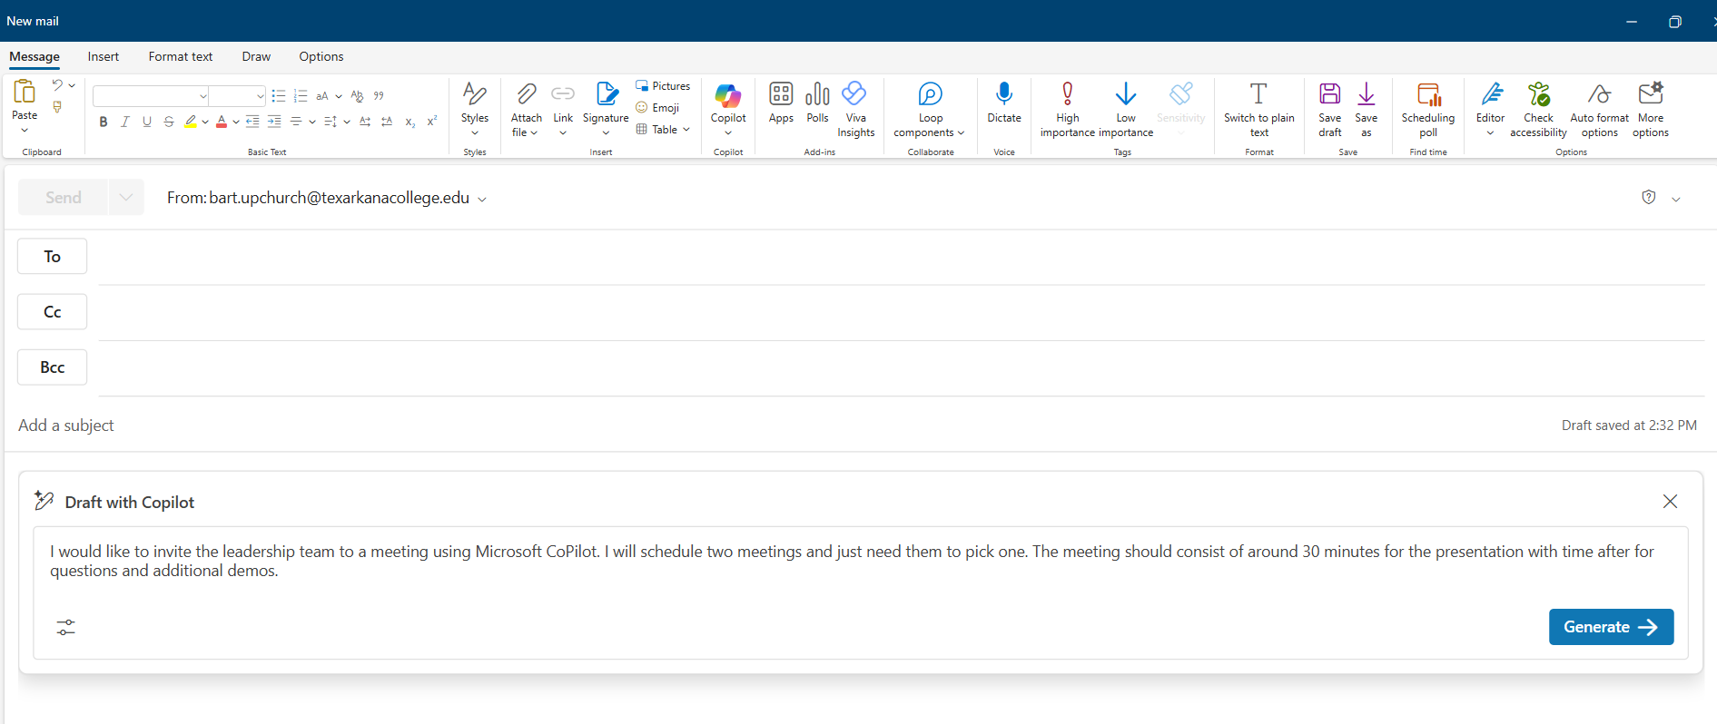

Generate to receive the next suggestion.
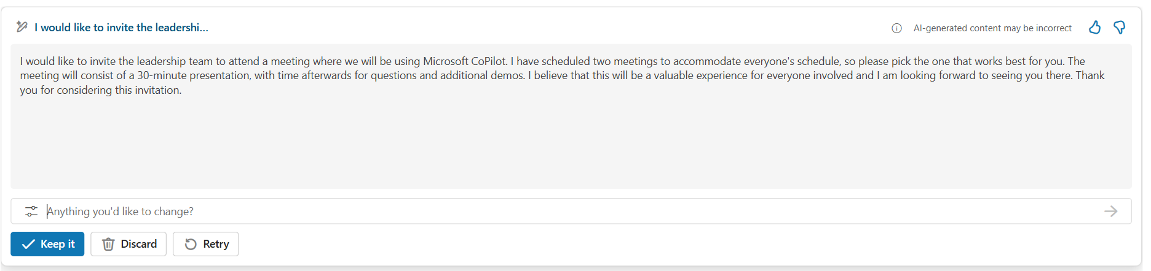
- Not the result we wanted, so we added in the following command (as seen in the next screenshot)
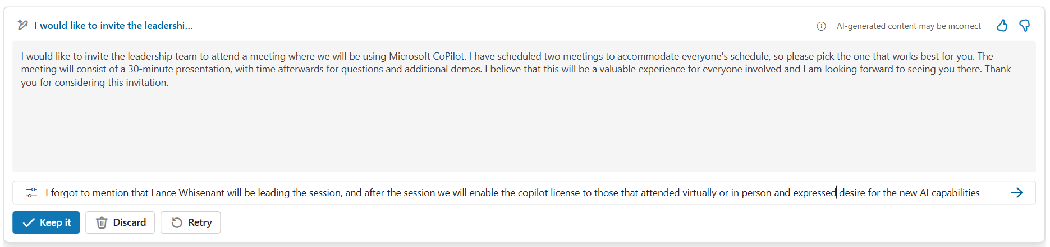
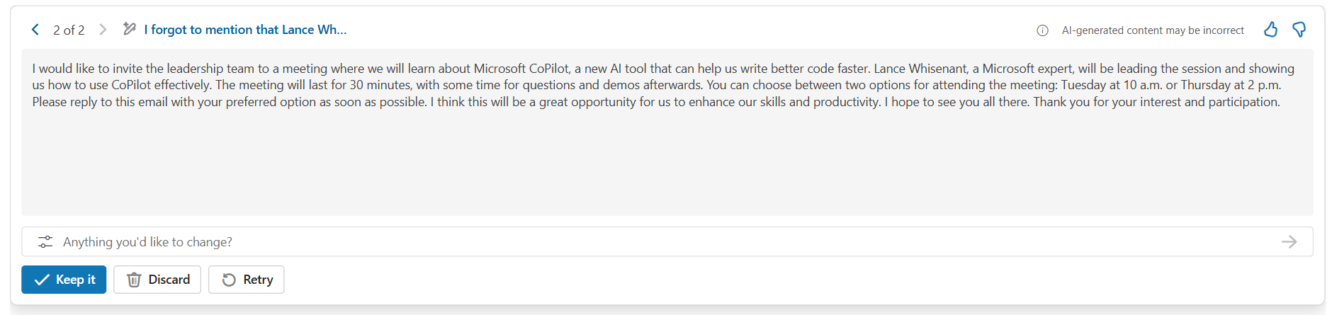

Feedback
- Not correct so we disliked the response and submitted feedback to improve the model’s performance.
- This is a VERY important part of the process as our feedback trains future models.
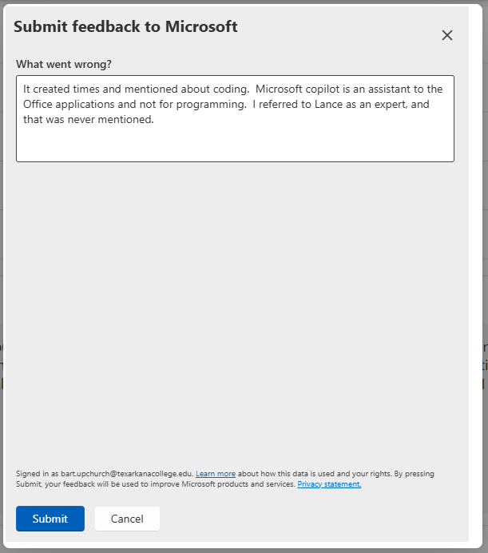
- Submitted the feedback and then clicked Retry.

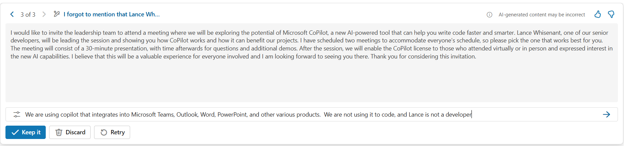
- Not a specific enough response, so additional instructions for clarification were added.

Final Result
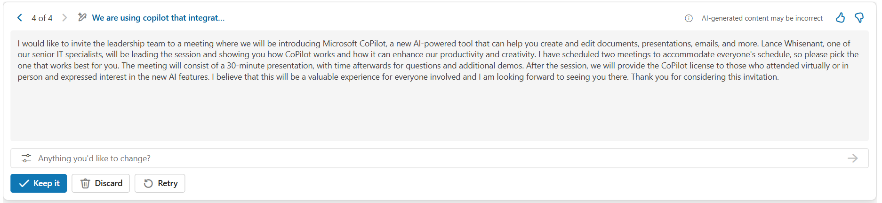
“I would like to invite the leadership team to a meeting where we will be introducing Microsoft CoPilot, a new AI-powered tool that can help you create and edit documents, presentations, emails, and more. Lance Whisenant, one of our senior IT specialists, will be leading the session and showing you how CoPilot works and how it can enhance our productivity and creativity. I have scheduled two meetings to accommodate everyone's schedule, so please pick the one that works best for you. The meeting will consist of a 30-minute presentation, with time afterwards for questions and additional demos. After the session, we will provide the CoPilot license to those who attended virtually or in person and expressed interest in the new AI features. I believe that this will be a valuable experience for everyone involved and I am looking forward to seeing you there. Thank you for considering this invitation.”

Coaching by Copilot
- https://www.microsoft.com/en-us/videoplayer-nocookie/embed/RW1jYGk?pid=ocpVideo1&maskLevel=20&market=en-us
- To take full advantage of this feature, it is important to ensure that your emails meet a minimum length requirement of at least 100 characters.
- This requirement helps ensure that the content of your emails is detailed and substantial, allowing Copilot to provide more accurate and useful feedback.
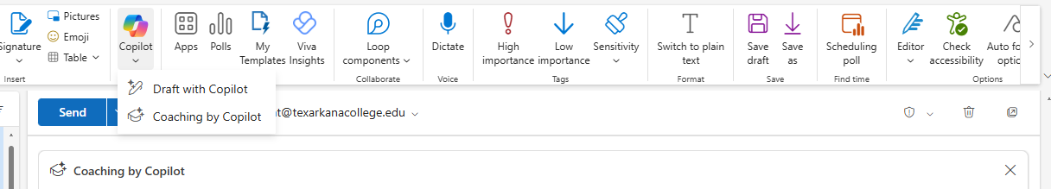
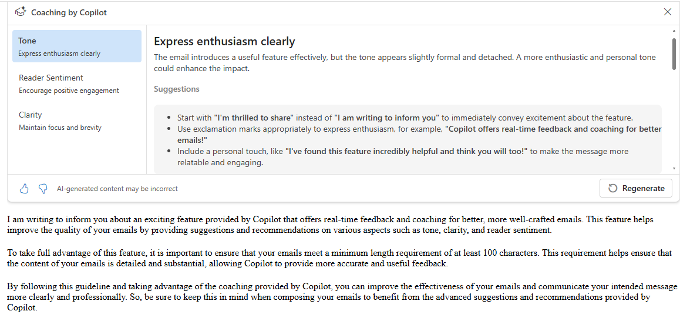
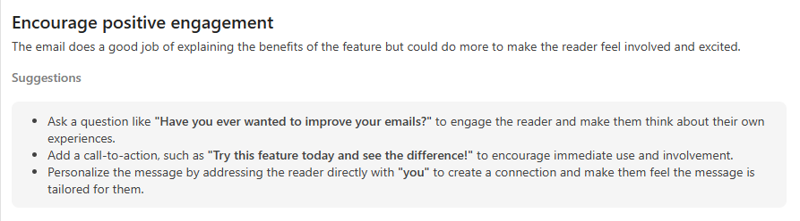
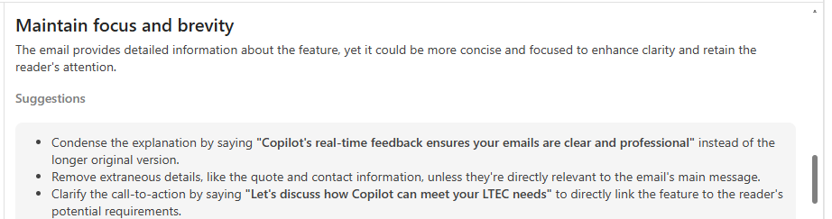
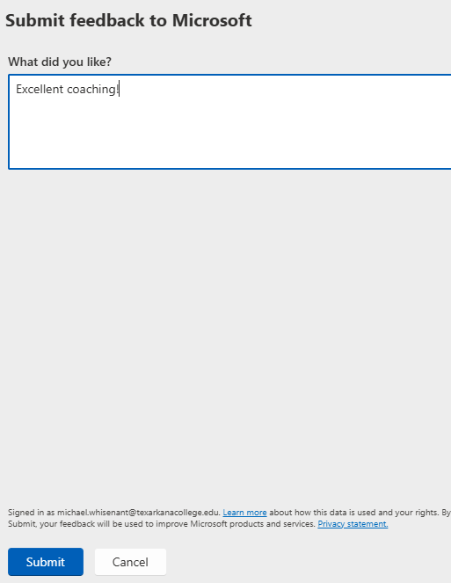
The End

